**Full name: …………………………………. MID-TERM TEST**

**Class:** …………………………… Subject: English 1(Listening +Reading + Writing)

Allotted time: 90 ms

1. **LISTENING (20 points) – LISTEN TWICE**

**Listen and put a tick into the correct box below the letter A, B, C on your answer sheet**

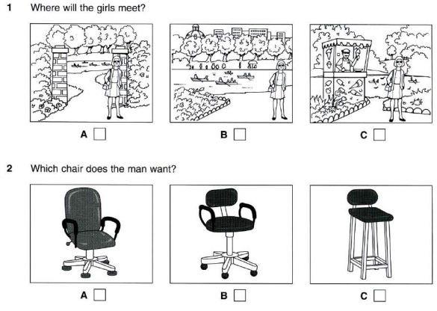

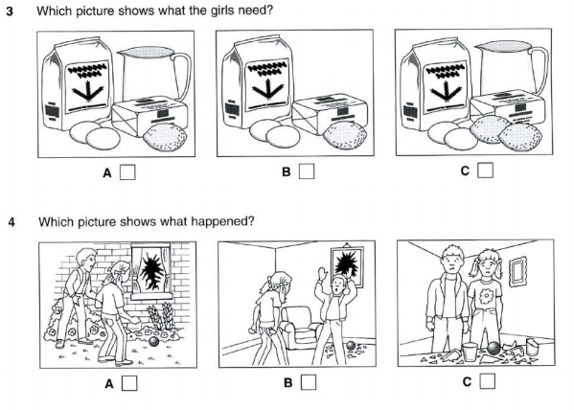

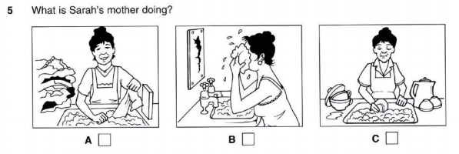

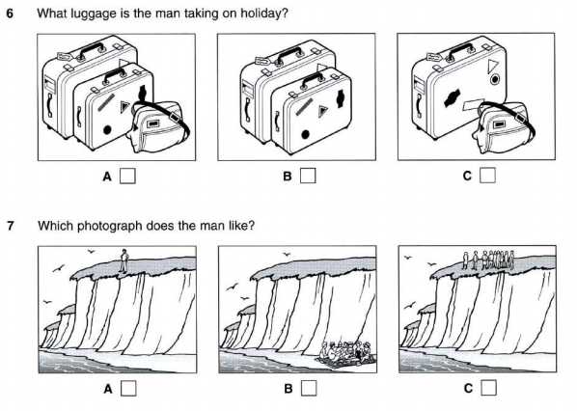

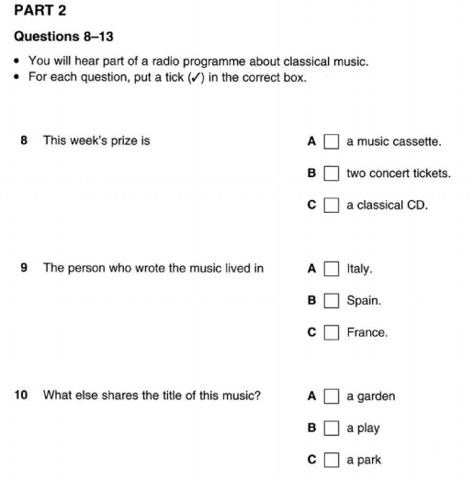

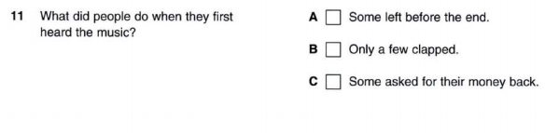

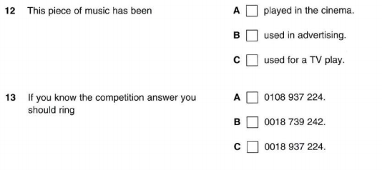

**PART 3**

**Question 14-20**

You will hear a radio programme in which young people from different parts of the country are interviewed.

For each question, fill in the missing information in the numberes space.

**INFORMATION SHEET**

Name: *Mike Davis*

Age: (14)………………………………………………………………

Favourite subject: (15)………………………………………………….

Favourite sport: (16) ……………………………………………………

Usual sport: (17) …………………………………………………………

On Saturday: (18) ……………………………………………………….

On: (19) ………………………………………: Young Farmers’ Group

Future job: (20) …………………………………………………………..



**B. READING (30 points)**

**PART I: (10 points) – CIRCLE the best answer**

1. She __________ Vietnam several times.

A. visit B. is visiting C. has visited D. visited

2. During her childhood, her parents __________ in Paris.

A. live B. lived C. have lived D. were living

3. He _________ for the same company since he left school.

A. works B. has worked C. worked D. was working

4. She __________ the bank. Please call her back later.

A. has gone out B. has been to C. has been out D. has gone to

5. I have not seen him __________ three years.

A. for B. since C. from D. at

6. The fish is....................thing on the menu.

A. the best B. goodest C. gooder D. better

7. Though he earns.................much money as I do, he always says he runs short of money.

A. as twice B. twice as C. so twice D. twice so

8. Any employee …………..….shows great performance will be rewarded.

A. which B. who C. whom D. whose

9. Sales staff member …………....….English is fluent will have a chance to move abroad.

A. who B. which C. whom D. whose

10. We issue a membership card …………..…..can be used in many facilities.

A. which B. who C. whose D. whom

**PART II (5 POINTS) – CIRCLE the best answer**

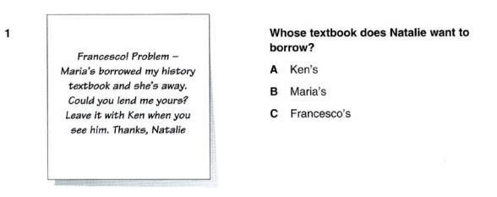

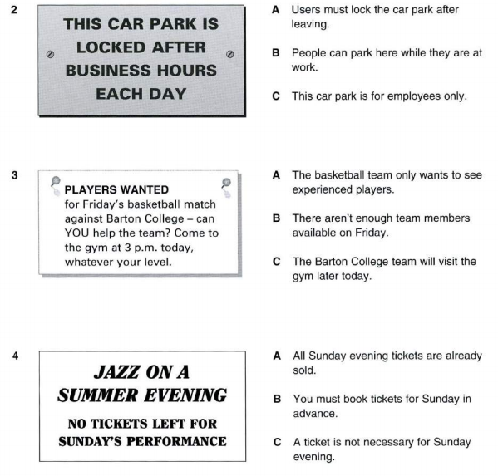

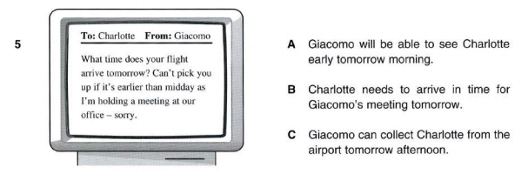

**PART III (5 points) – CIRCLE the best answer**

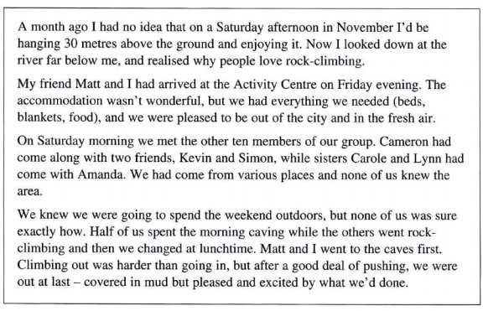

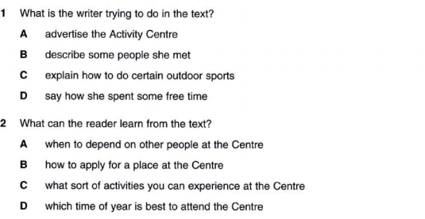

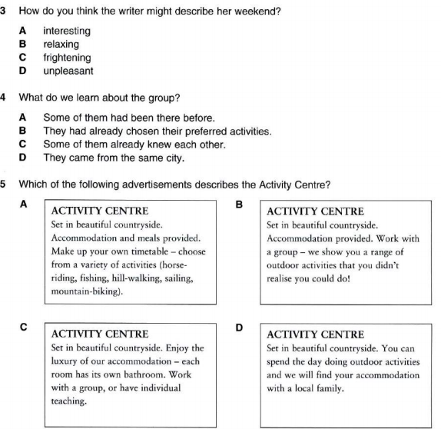

**PART IV- (10 points) Complete each blank of the reading text with ONE suitable word.**

**THE FIRST WOMAN SCIENTIST**

Hypatia was born in Alexandria, in Egypt, in 370 A.D. For many centuries she was (1) ……………… only woman scientist to have a place in the history books.

Hypatia’s father was director of Alexandria University, and he (2) ……………. sure his daughter had the best education available. This was unusual, as most women then had few (3) ………………. to study.

After studying in Athens and Rome, Hypatia returned to Alexandria (4) ……………. She began teaching mathematics. She soon became famous (5) …………… her knowledge of new ideas.

We have no copies of her books, (6)……………. we know that she wrote several important mathematical works. Hypatia was also interested in technology and (7)…………. several scientific tools to help with her work.

At the (8) ……………. many rulers were afraid of science, and (9) ………….. connected with it was in danger. One day in March 415, Hypatia (10) ……………. attacked in the street and killed.

1. A. one B. the C. a D. an

2. A. could B. made C. said D. put

3. A. classes B. customs C. opportunities D. teachers

4. A. where B. how C. there D. which

5. A. from B. by C. for D. in

6. A. because B. but C. or D. as

7. A. did B. experimented C. invented D. learnt

8. A. day B. period C. year D. time

9. A. anyone B. nobody C. all D. something

10. A. was B. had C. has D. is

**C. WRITING (30 points)**

**PART I (10 points)**

**Complete the second sentence so that it has a similar meaning to the first one**.

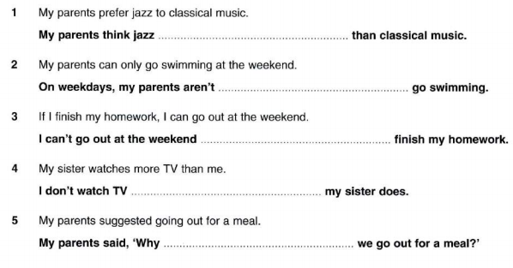

**PART II (20 POINTS)**

Write a paragraph of 100-120 words about the advantages OR disadvantages of shopping online. Use supporting ideas to develop your opinion.

*.*

*..................................................................................................................................................................................................................................................................................................................................................................................................................................................................................................................................................................................................................................................................................................................................................................................................................................................................................................................................................................................................................................................................................................................................................................................................................................................................................................................................................................................................................................................................................................................................................................................................................................................................................................................................................................................................................................................................................................*

*.......................................................................................................................................................................***---THE END --**